Style Guidelines for Final Year Project ReportsLiveStock Supervision

**Sameer Waheed**

**Hamza Khan**



DEPARTMENT OF COMPUTER SCIENCES

COMSATS UNIVERSITY ISLAMABAD,

ATTOCK CAMPUS – PAKISTAN

SESSION 2018-2021

Style Guidelines for Final Year Project ReportsLiveStock Supervision

*Undertaken By:*

**Sameer Waheed**

Sp18-bcs-033

**Hamza Khan**

Sp18-bcs-004

*Supervised By:*

Mr. Shahzad Rizwan

A DISSERTATION SUBMITTED AS A PARTIAL FULFILLMENT OF THE REQUIREMENTS FOR THE DEGREE OF BACHELOR OF SCIENCE IN

SOFTWARE ENGINEERING

SESSION 2018-2021

DEPARTMENT OF COMPUTER SCIENCES

COMSATS UNIVERSITY ISLAMABAD,

ATTOCK CAMPUS – PAKISTAN

|  |  |  |  |  |  |  |
| --- | --- | --- | --- | --- | --- | --- |
| **PROJECT ID** | |  | |  | **NUMBER OF MEMBERS** | 2 |
| 222 | | | | | | |
| **TITLE** | Livestock Supervision | | | | | |
|  | | | | | | |
| **SUPERVISOR NAME** | | | Mr. Shahzad Rizwan | | | |

|  |  |  |
| --- | --- | --- |
| **MEMBER NAME** | **REG. NO.** | **EMAIL ADDRESS** |
| Sameer Waheed | CIIT/ Sp18-bcs-033/ATK | Sameerwaheed1997@gmail.com |
| Hamza Khan | CIIT/ Sp18-bcs-004/ATK | hk2598689@gmail.com |

**CHECKLIST:**

|  |  |  |  |
| --- | --- | --- | --- |
| Number of pages in this report |  |  |  |
| I/We have enclosed the soft-copy of this document along-with the codes and scripts created by myself/theselves | **YES / NO** | | |
| My/The supervisor has attested the attached document | **YES / NO** | | |
| I/We confirm to state that this project is free from any type of plagiarism and misuse of copyrighted material | **YES / NO** | | |

|  |  |  |
| --- | --- | --- |
| **MEMBERS’ SIGNATURES** |  | |
|  |  | Supervisor’s Signature |
|  |  |
|  |  |

This work, entitled **“Livestock Supervision”** has been approved for the award of

**Bachelors of Science in Computer Science**

***Committee:***

1. External Examiner ____________________________

2. Supervisor ____________________________

1. Head of Department ____________________________

UNDERTAKEN

We certify that this is my/the own work. The work has not, in whole or in part, been presented elsewhere for assessment. Where material has been used from other stheces it has been properly acknowledged. If this statement is untrue, we acknowledge that we will have committed an assessment offence and shall be liable to punishable action under the plagiarism rules of HEC.

______________ ____________________

Sameer Waheed Hamza Khan

Sp18-BCS-033 Sp18-BCS-004

Dated: _________ Dated: _________

**ACKNOWLEDGEMENT**

We are thankful to ALLAH Almighty the most beneficent and the merciful. May Allah shower all his blessings on us. We are grateful to ALLAH that he has provided us different types of restheces and make us eligible to advantages from these restheces to help human beings.

We are grateful for all that the parents do for us, there is no way of repaying them. We are thankful for their support and their prayers, without them we are nothing. We are always supported and motivated by them in every condition of life whether it is finically.

We are thankful to **Mr. Shahzad Rizwan** for his guidance and for motivating us to work hard. He has supported us in every step. Without his help, we would not able to achieve this goal. We found him very helpful while discussing the issues.

**ABSTRACT**

A huge chunk of the country’s economy is based upon agriculture (livestock). But, as compared to the international standards, the livestock sector is diminishing day by day. The reason is non-automation of the ongoing businesses of agricultural and livestock activities. By keeping in mind all the serious issues regarding livestock; development of an automated system is required. Hence, this project is an Android-based application “Livestock supervision”; which will facilitate farmers in sale-purchase, consultancy given by a veterinary and products related to farming like livestock (animal) feed etc. Consultant/assistant (a veterinary) will handle animal diseases and medication required for such cases. A shop keeper (sales person) will also be included in the system for the sale of products required/wanted by the customers (buyer).

Contents

**Chapter 1** 1

**Introduction** 1

**1. Introduction** 2

**1.1.** **Problem Statement** 3

**1.2.** **Solution to the Problem** 3

**1.3.** **Objective** 3

**1.4.** **Benefits** 4

**Chapter 2** 4

**Literature Review** 4

**2.** **Literature Review** 5

**2.1.** **Existing Applications** 5

**2.1.1.** **My Farmer App** 5

**Chapter 3** 8

**Requirement Analysis** 8

**3. Requirement Analysis** 9

**3.1.1. Registration for Users** 9

**3.1.2. Login for Farmer** 10

**3.1.3. Login for Shopkeeper** 10

**3.1.4. Customer Location** 11

**3.1.5. Placing Feed Order** 11

**3.1.6. Search Bar** 12

**3.2. Non-Functional Requirements** 12

**3.2.1. Reliability** 12

**3.2.2. Availability** 12

**3.2.3. Robustness** 12

**3.2.4. System Modification** 12

**3.2.5. Security** 13

**3.2.6. Resthece Issues** 13

**3.2.7. Hardware Consideration** 13

**Chapter 4** 14

**Design & Architecture** 14

**4.1. Architecture** 15

**4.2. Methodology** 15

**4.2.1. First Increment:** 16

**4.2.2. Second Increment:** 16

**4.2.3. Third Increment:** 16

**4.2.4. Fifth Increment:** 16

**4.3. Use Case Diagram** 16

**4.3.1. Farmer Use Cases** 17

**4.3.2. ShopKeeper Use Case** 18

**4.3.3. Cosultant Use Case** 19

**4.4. Architecture Overview** 20

**4.4.1. ShopKeeper Activity Diagram** 20

**4.4.2. Consultant Activity Diagram** 22

**4.5. Sequence Diagram** 23

**Table of Figures**

Figure 1. 1 My Farmer 6

Figure 1. 2 Comparison table 7

Figure 4. 1 Incremental SDLC Model 15

Figure 4. 2 farmer Use Case 17

Figure 4. 3 Shopkeeper Use Case 18

Figure 4. 4 Consultant Use Case 19

Figure 4. 5 shopkeeper Activity Diagram 20

Figure 4. 6 farmer Activity Diagram 21

Figure 4. 7 consultatn Activity Diagram 22

Figure 4. 8 Customer Sequence Diagram 23

Figure 4. 9 shopkeeper Sequence Diagram 24

Figure 4. 10 Farmer Sequence Dia 25

**Table of Tables**

Table 3. 1 FR of Users Registration 9

Table 3. 2 FR of Login Farmer 10

Table 3. 3 FR of shopkeeper Login 10

Table 3. 4 FR of Users Location 11

Table 3. 5 FR of Placing feed Order 11

Table 3. 6 FR of Search Bar 12

**Chapter 1**

**Introduction**

**Project Abstract:-**

A huge chunk of the country’s economy is based upon agriculture (livestock). But, as compared to the international standards, the livestock sector is diminishing day by day. The reason is non-automation of the ongoing businesses of agricultural and livestock activities. By keeping in mind all the serious issues regarding livestock; development of an automated system is required. Hence, this project is an Android-based application “Livestock supervision” which will facilitate farmers in sale-purchase, consultancy given by a veterinary and products related to farming like livestock (animal) feed etc. Consultant/assistant (a veterinary) will handle animal diseases and medication required for such cases. A shop keeper (sales person) will also be included in the system for the sale of products required/wanted by the customers (buyer).

# **Introduction**

This project is based upon the idea of the working of livestock supervision. A number of different features will be integrated in the project that will ease the ways of performing farming-related activities. A sale-and-purchase system will be executed via which the user can sale a product and/or buy a product. Each user will get a specific ID after registration in the app. A veterinary will also be part of the system that will assist and consult the farmer (users) in various ways including medication procedures for farm animals etc. Recommendation system will be implemented throughout the application that will work in different ways i.e. recommending a medicine for animals that will be at the top of the list, the most used feed will be recommended and so forth.

The application will be composed of three user interfaces. These include a separate interface for the users (customers/buyers). A separate UI for the shopkeeper/s. And a separate one for the veterinary (consultant). The shopkeeper is acting as the Owner (admin) of the application and available products in the system are present in shops and farms of the owner.

* 1. **Problem Statement**

This case study looks at the problem of the farmer finding best feed for the animals.:

* For putting in any requests they need to visit the feed shop and buy it in various cities.In Some villages there is no feed shop to buy them
* For taking guidance they need to visit and hang tight for an advisor for exhortation.
* There is another issue identified with taking care of there is exceptionally hard to track down moving feed as per place.
  1. **Solution to the Problem**

Today as we know that android phone users are increasing rapidly. To solve this problem, we proposed to develop an android application “LiveStock supervision”, originally designed for a small-scale business. The main advantages of my system are that it for ease of farmers to buy feed and can take advice from consultants.

Provide an online android based application for general Farmers , consultants and shopkeepers.

* Without wasting time easily take advice from consultants.
* For more secured ordering feeds separate accounts are maintained for each user by providing them an ID and a password.
* The system will be less likely to commit errors since it's a machine.
  1. **Objective**

The main goal of the project is to provide an interface for Farmer and shopkeeper of livestock supervison.

* This application for farmer and shopkeeper without wasting time, an app allowed to hire a feed item from shopkeeper when required, and famer easily online find and track place.
* The farmer and the shopkeeper can check reviews about the new items at any order to judge performance with the help of other user’s feedback.
* To build up an application that will surely satisfy the shopkeeper and managed a large number of orders or requests at a time accepted (one after another).
* To develop an effective and efficient application for different users.
  1. **Benefits**
     1. **Time-Saving:**

The guideline base is on time since time is what we need most, yet we use the most perceptibly awful. Solicitation Feeds for animal online through an application is additionally a viable other alternative, particularly at whatever point the user don't get the opportunity to visit a shop. Through the application, the solace for Farmer has extended an incredible arrangement realted to take care of which are moving on base of region and animal, the user can orchestrate feed in minutes, get it passed on to ythe home, and eat at the solace of ythe place, and furthermore to accept brisk guidance realted to animal effectively and productively.

* + 1. **Reliability:**

It's a reliable stage where people can speak with each other concerning their Farmer and money manager to arrangement and buy feed. Here Farmer will have a feeling of security and straightforwardness to look at an issue with consultant and interest online adequately

* + 1. **Efficient**

If there is any problem or query to any farmer, he/she can directly contact to us we will efficiently reply in about half-hthe and solve their queries.

**Chapter 2**

**Literature Review**

## **Literature Review**

## There are numerous well-known android applications utilized around the planet. These applications fluctuate in their highlights and subtleties as per their utilization and district. We did a broad examination and discovered just comparable applications being utilized in India. Some of them are Pakistan's applications yet most applications are utilized for India. In the application, we have added a couple of new functionalities which are not in other existing applications like proposal framework for the rancher.

## **Existing Applications**

In a current application for giving any solicitations, a farmer should visit Shop or Feed Place to consider feed things and by then give demands and pay early or the user need to pick a feed from menu and present a solicitation open if the need emerges. In this strategy, time and manual work is required. Keeping up essential information in the records and manuals is stacked with peril and dreary cycle. Following of Delivery isn't open in past applications.Customization of Order, Current status of the solicitation isn't open. A couple of utilizations contain an out of date data identified with feed.

There are right now 1 application name as MY Farmer App. By analysing the study, we come to the choice that MY Farmer App. require 30% of follow-up concerning the request is put or not? What's more, a request is dispatched or not? What's more.

## **My Farmer App**

MyFarm is a livestock farm management application that helps livestock farmers optimize the performance of their farms and increase their productivity and profits.

 MyFarm gives the farmer decision-making tools with fast, easy data entry, and flexible yet powerful reporting.All core livestock farming information can be recorded, including animal data, servings, births, deaths, comments, medicines, revenue, expenditure, weights, etc. MyFarm has the following features,

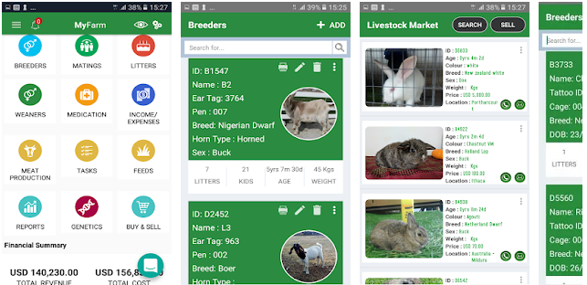

Figure 1. 1 My Farmer

**Proposed System:**

In this project, we solve many problems like difficult user interface problems, a problem in easily ordering trending feed after evaluating systems and applications.

In the application there many unique features available. The Farmer easily orders the feed and the chef easily takes many orders at a time. Farmer and Consultant can easily communicate with each other and discuss many problem. In this application, we add a Recommender system for both of us according to their interest.

**Comparison Table :**

The comparison table is given below which determine what’s new featrure are added in current system.

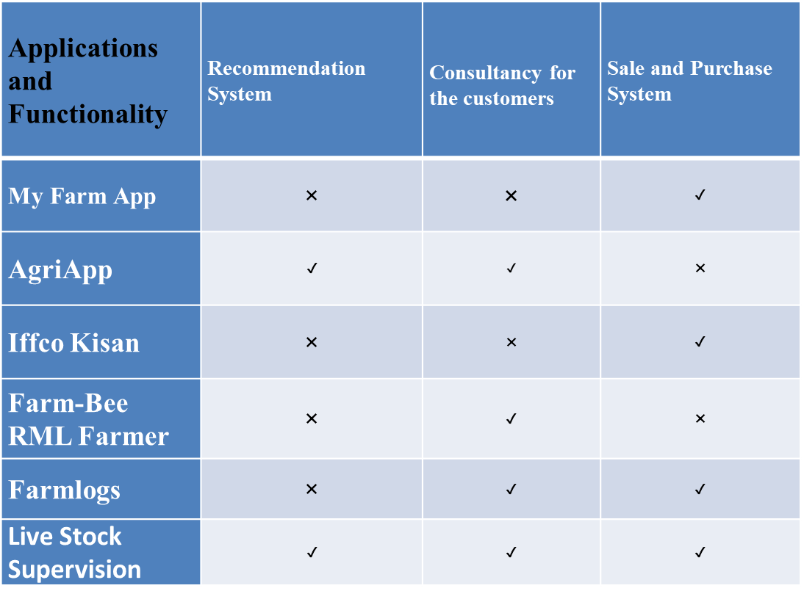

Figure 1. 2 Comparison table

**Chapter 3**

**Requirement Analysis**

### **3. Requirement Analysis**

This part clarifies the practical and non-utilitarian necessities of the product which we are creating. The utilitarian prerequisite will clarify what the framework is relied upon to do. The practical necessity clarifies the conduct of the framework and its segment dependent on specific information. It will clarify diagrammatically the approaching section by utilizing the utilization case outlines. This necessity will determine what the framework should do. These necessities are tried in the testing stage and the outcome will be gotten which will be utilized in the evaluation. These clarify the conduct of the framework while the non-utilitarian prerequisite is the limitations. The non-practical prerequisite will be satisfied to make the framework is more proficient and powerful. It characterizes the property of the framework. Toward the finish of this part, the equipment and programming usage will be clarified. Prior to going to useful and non-practical prerequisites, we see a few wordings which are given beneath. Allow us to examine in detail.

**3.1. Functional Requirement**

This section will provide the user with information about the functional requirements of the project.

### **3.1.1. Registration for Users**

Table 3. 1 FR of Users Registration

|  |  |
| --- | --- |
| Name | **FR-1: Registration** |
| Summary | User must register him/herself with a pic to see the functionalities of  “LiveStock Supervision”. |
| Rationale | To keep the data of app user will be separate. |
| Requirements | User will be entered in-app by giving the Name, Email, password and phone number, CNIC, location with the type (Farmer, ShopKeeper). |

### **3.1.2. Login for Farmer**

Table 3. 2 FR of Login Farmer

|  |  |
| --- | --- |
| Name | **FR-2: Login** |
| Summary | User Must be Login On “Livestock supervision” application to see Farmer details then hire, order feed., view all type of Consultants, to check own profile. |
| Rationale | To Keep track of the user activities and store them in an application for future use. |
| Requirements | User will be entered into the Application by giving the correct email and password |

### **3.1.3. Login for Shopkeeper**

Table 3. 3FR of shopkeeper Login

|  |  |
| --- | --- |
| Name | **FR-3: Login for Shopkeeper** |
| Summary | An Shopkeeper must be login to use the functionalities of LiveStock Supervision Services. |
| Rationale | To keep the data of each user separately. |
| Requirements | The shopkeeper sees all accounts and their request and also view order details. |

### **3.1.4. Customer Location**

Table 3. 4FR of Users Location

|  |  |
| --- | --- |
| Name | **FR-7: Users Location** |
| Summary | Users can mention the exact location of their place. |
| Rationale | To keep providing user's location. |
| Requirements | Users will provide their location. |

### **3.1.5. Placing Feed Order**

Table 3. 5 FR of Placing feed Order

|  |  |
| --- | --- |
| Name | **FR-8: Placing Feed Orders** |
| Summary | Farmer must place their orders. |
| Rationale | To keep the record of each user-selected items in each session. |
| Requirements | A farmer will provide their location. |

### **3.1.6. Search Bar**

Table 3. 6 FR of Search Bar

|  |  |
| --- | --- |
| Name | **FR-9: Search Bar** |
| Summary | Farmer must search for the Feed. |
| Rationale | To search the Shopkeeper and products by Farmer. |
| Requirements | Farmer will search for the Shopkeeper and Feed to hire. |

## **3.2. Non-Functional Requirements**

### **3.2.1. Reliability**

This proposed System which a designer configuration is more dependable, effective, and easy to use. Its proficiency cooperates with the client. Secure admittance to utilize private information. The proposed framework in which the engineer plans are solid as they effectively interface with clients. Secure admittance to secret information.

### **3.2.2. Availability**

Internet Connection is available at any time. As availability will be provided if the internet connection will be available.

### **3.2.3. Robustness**

The system cannot be lost the app user’s information like hiring persons etc. These will be permanently stored and the user can delete them.

### **3.2.4. System Modification**

This system is more flexible and all modifications will be done by the Farmer , Shopkeeper Like Add new treding feed items managing orders of a user. Auction corner is generating by the customer.

### **3.2.5. Security**

All user’s data will be Store in Goole Product Named Firebase. The only Developer can access that data. The second person cannot access the details of the LiveStock Supervision application other than the owner.

### **3.2.6. Resthece Issues**

Restheces of the computer should meet the hardware considerations. Anything less than this is not enough proper functioning of the system.

### **3.2.7. Hardware Consideration**

RAM: 3GB (Minimum Required)

Free Space: 1GB (Minimum Required)

Operating System: Android (Above 5.1 Lollipop version)

**Chapter 4**

**Design & Architecture**

#### **Design and Architecture**

This chapter discusses the design of the project.

* 1. **Architecture**

Here are some diagrams that will describe the basic architecture of the system, how components and activities in the system work and collaborate at regular and specified intervals.

* 1. **Methodology**

In The incremental SDLC (System Development Life Cycle) model, the project is divided into a smaller number of increments and each increment has a phase with time-lapse. The first increment is often a core product with many supplementary features in this method.

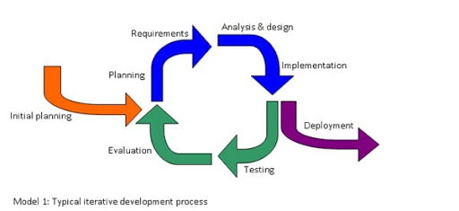

Figure 4. 1 Incremental SDLC Model

The development process model which we are using in the project is the incremental model. In this, we broke the project requirement into increments for the software development cycle. We have selected this model to make projects in increments and then show the supervisor if any change is required so that can be done easily and efficiently.

### **First Increment:**

* Login For Farmer
* Login For Shopkeeper
* Login For Consultant
* Registration Page for users
* Front end design of all page (prototype)

### **Second Increment:**

* Farmer Module
* Searching Shopkeeper
* Uploading pic
* Updating own details
* View Shopkeeper
* Hire Shopkeeper or their feed items.
* Show dishes& order Feed

### **Third Increment:**

* Shopkeeper Module
* Add Items (Feed)
* Uploading pic
* Updating own details
* View Feed and rating
* Add Feed Delievery Location

### **Fifth Increment:**

* App Integrating Module
* Integration with Google
* Integration with Authentication
  1. **Use Case Diagram**

The Use case diagram is a diagram that shows the behavior of the system which we are developing. Use Case represents the functionality of the program. Actors are the primary persons who operate on the system. The actor must be associated with at least one use case.

### **Farmer Use Cases**

-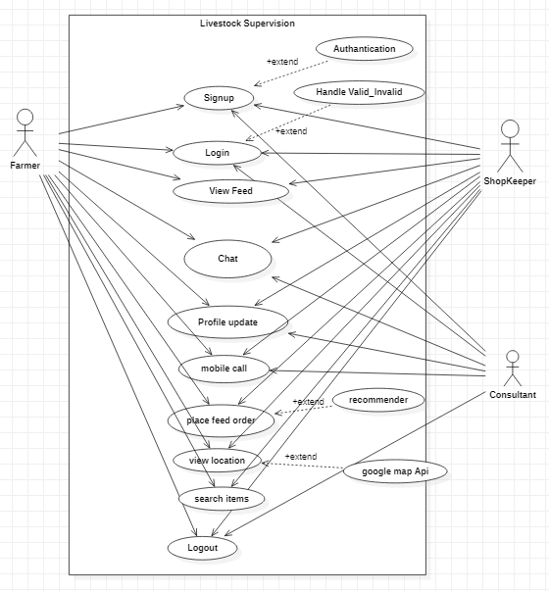

Figure 4. 2 Farmer Use Case

Figure 4‑2 shows the farmer behavior of the system. The farmer will be entered in the application but before he will register himself/herself. Two options Sign in and Sign up will show in front of the page. If the farmer needs signup so, he will choose

signup and then login. After Login he will be seen and perform the functionalities of the system. He can update his profile. He can see shopkeeper, feed , feed video, and also see a notification if he hires a shopkeeper then a response will have come in a notification. He can search the person in modules. and also search for items, etc. Customers will see the location of that shopkeeper and can determine which is nearest.

### **ShopKeeper Use Case**

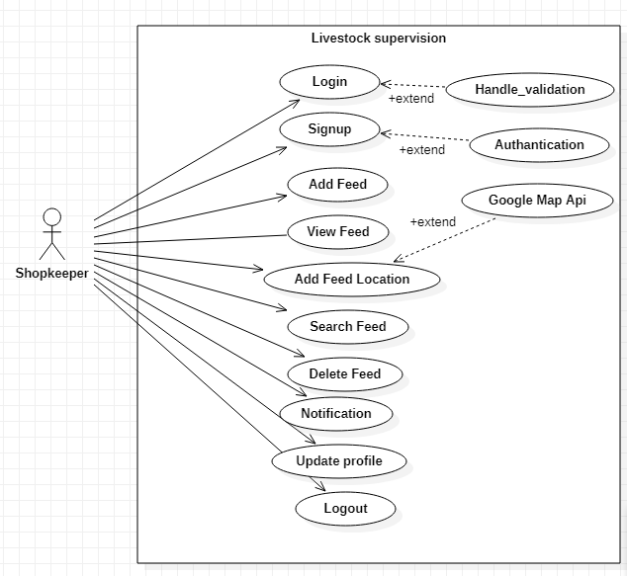s9

Figure 4. 3 Shopkeeper Use Case

Figure 4‑3 shows the Shopkeeper behavior of the system. The Shopkeeper will be entered in the application but before he will register himself. Two options Sign in and Signup will show in front of the page. If the Shopkeeper needs signup so, he will choose signup and then

login. After Login he will be seeing and perform the functionalities of the system. He can update his profile. A shopkeeper can add feed items, and view order requests these requests are view on the notification side. He can see all Shopkeeper and their location. He can search for the location and deliver feed.

### **Cosultant Use Case**

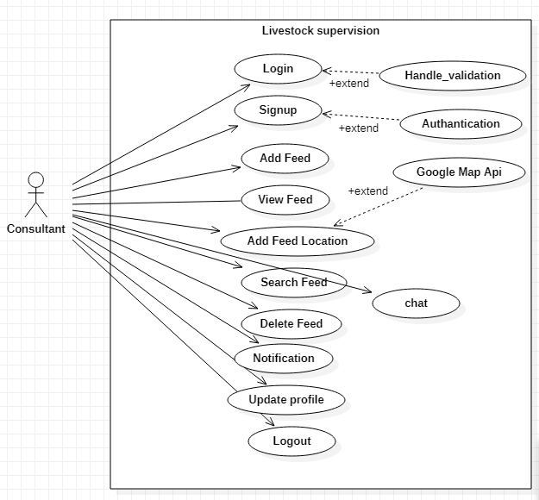

Figure 4. 4 Consultant Use Case

Figure 4‑4 shows the Consultant behavior of the system. Consultant will be entered in an application then Login he will be seeing and perform the functionalities of the system. He can update his profile and see message to all farmer. Consultant can see items, and view.

* 1. **Architecture Overview**

In this section, there is some diagram which will describe the architecture of over system which we are developing. The diagram will show how the system’s components interact with each other.

### **ShopKeeper Activity Diagram**

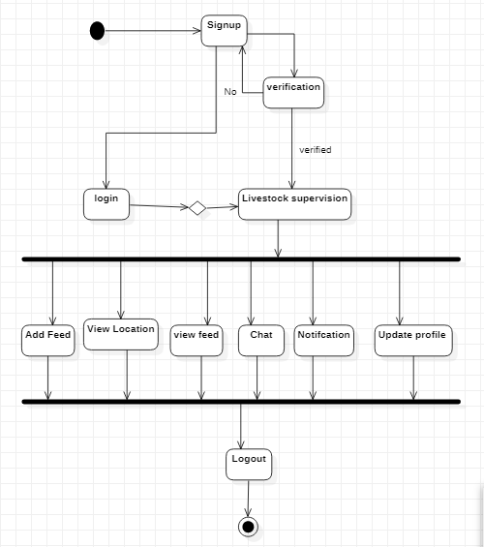

Figure 4. 5 Shopkeeper Activity Diagram

Figure 4-5 shows there is an activity performed by Shopkeeper where he simply logs in to enter in Online livestock supervision services app and can view feed, order feed, searching new items feed, update profile. He can view their location and hire them. He also hires and sees the response of that person who hires him in a notification. The customer will add items and order food at a normal price. After performing functionalities of the app he can log out simply.

**Farmr Activity Diagram**

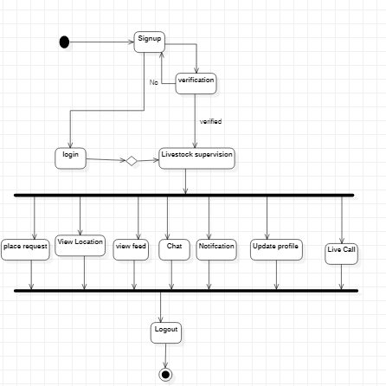

Figure 4. 6 Farmer Activity Diagram

Figure 4-6 shows there is an activity performed by farmer where he simply logs in to enter in Online livestock supervision app and can view Shopkeeper, reviews, notifications and also see their location. After performing functionalities of the app he can log out simply. He can see the View of the list of Shopkeeper and their location. He also can see his rating. After performing functionalities of the app he can log out simply.

### **Consultant Activity Diagram**

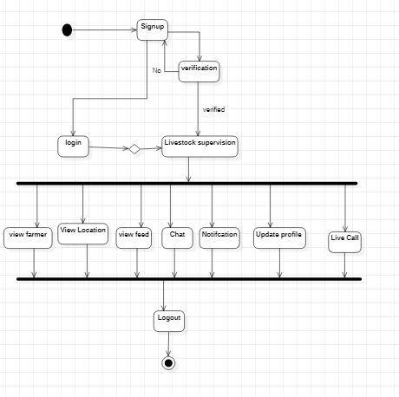

Figure 4. 7 Consultant Activity Diagram

Figure 4-7 shows there is an activity performed by admin where he simply logs in to enter in Online livestock supervision. They can view the items with descriptions Like name and price, approve chef or Shopkeeper request, update profile, also handle forget the password, etc. in the application. He can see the location.

* 1. **Sequence Diagram**

The sequence diagram is as follow

* + 1. **Consultant Sequence Diagram**

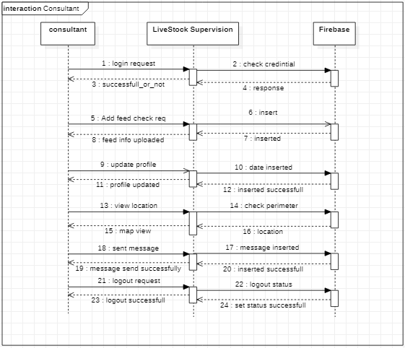

**Figure 4. 8 Customer Sequence Diagram**

* + 1. **Shopkeeper Sequence Diagram**

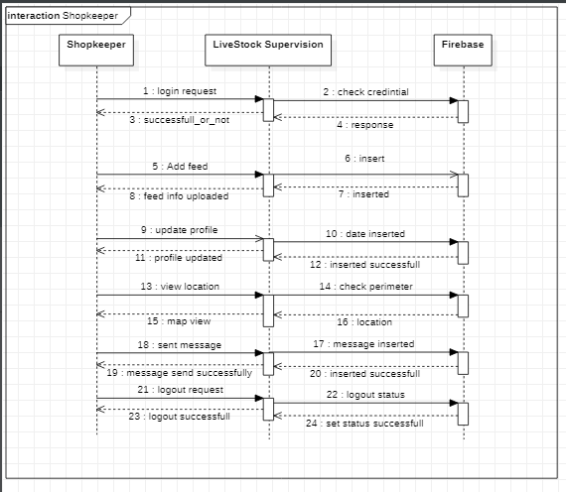

Figure 4. 9 Shopkeeper Sequence Diagram

* + 1. **Farmer Sequence Diagram**

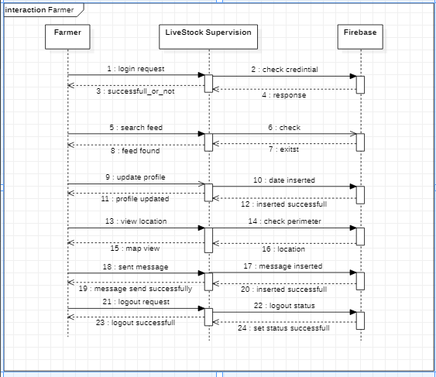

Figure 4. 10 Farmer Sequence Dia

* + 1. Class Diagram

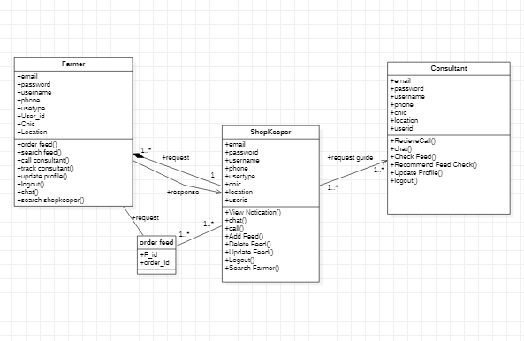

**Figure 4. 10 Class Diagram**